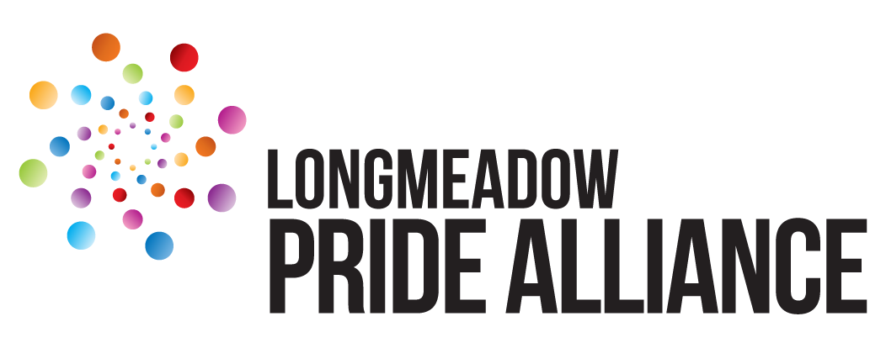
Business/Non-Profit Sponsorship Form

One of the best ways to support Longmeadow Pride Alliance is to become a sponsor. Sponsorships are available at a variety of levels with numerous perks. The goal of the LPA is to foster pride, equality, and respect for all LGBTQ+ communities in Longmeadow, MA and beyond. Our signature event is the Longmeadow Pride Festival, taking place this year on Sunday, September 13th, 2026.

Sponsorship benefits are outline on the following page.

Date:

Organization Name:

Address:

Authorized Representative Name:

Email:

Phone:

Sponsorship Levels:
Presenting Sponsor $3000+ Ally $500+
Advocate $1500+ Patron $250+
Partner $1000+ Friend $125+

We will donate: $

We would like to have a booth at the event: Yes No

We would like to provide Goods or Services to the event: Yes No

We will provide:

We would like to provide Volunteers from our organization for the event: Yes No

Please make check payable to Longmeadow Pride Alliance, Inc.
Mail to 241 Park Dr., Longmeadow, MA 01106
Please send the form to and contact Elizabeth Morgan (elizabeth@longmeadowpride.org) with any questions.

Longmeadow Pride is a 501(c)(3) non-profit. All donations are tax deductible.
EIN 87-1637147

Longmeadow Pride 2025 Sponsorship Benefits

Presenting Sponsor ($3000+)
* Named as a Presenting Sponsor of the event
* Prominent logo and/or company name on event poster
* Company recognition on all promotional materials
* Inclusion of logo and hyperlink on website
* Ongoing mentions on social media posts
* Acknowledgement from the stage during Pride Festival
* Signage at the stage during Pride Festival
* Special mention on social media
* Prime booth space at Pride Festival

Advocate ($1500+)
* Prominent logo and/or company name on event poster
* Company recognition on all promotional materials
* Inclusion of logo and hyperlink on website
* Ongoing mentions on social media posts
* Acknowledgement from the stage during Pride Festival
* Signage during Pride Festival
* Special mention on social media
* Booth space at Pride Festival

Partner ($1000+)
* Logo and/or company name on event poster
* Inclusion of logo and hyperlink on website
* Acknowledgement from the stage during Pride Festival
* Signage during Pride Festival
* Special mention on social media
* Booth space at Pride Festival

Ally ($500+)
* Logo and/or company name on event poster
* Inclusion of logo and hyperlink on website
* Signage during Pride Festival
* Special mention on social media
* Booth space at Pride Festival

Patron ($250+)
* Signage during Pride Festival
* Special mention on social media
* Booth space at Pride Festival

Friend ($125+)
* Special mention on social media
* Non-retail Booth space at Pride Festival

